Second line should print sum of A 0 1, A 1 0, A 1 2, A 2 1

First line should print sum of A 0 0, A 0 2, A 1 1, A 2 0, A 2 2

Output format

First and only line contains the value of array separated by single space

Input Format

A 1 0, A 1 2, A 2 1.

1 1, A 2 0, A 2 2 and A 0 1,

And print its sum. It should print two dierent numbers the rst being sum of A 0 0, A 0 2, A

alternate elements of the array

You are given a two-dimensional 3\*3 array starting from A [0][0]. You should add the

Question text

Question 1

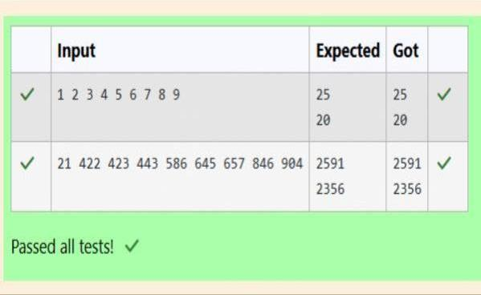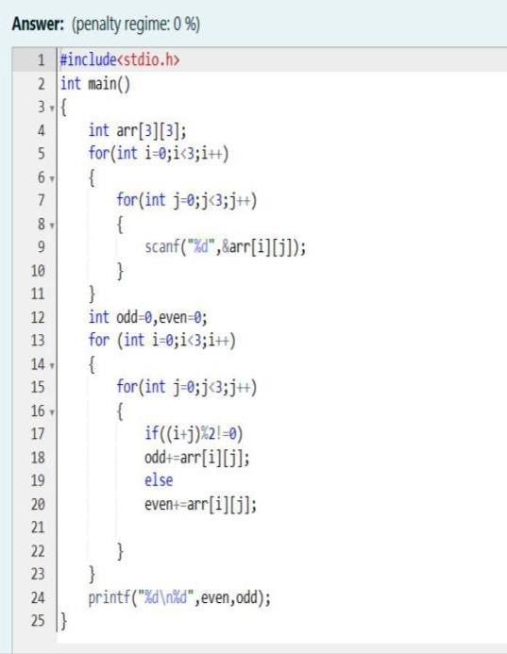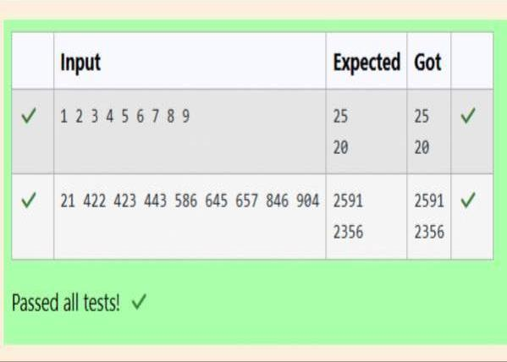

Help Shyam Lal to accomplish this task.

the co-ordinate axis. Now nd the Total amount of money, he has to return to the farmers.

blocks Where each block is equivalent to a unit square area which can be represented on

purchased from him. Suppose, Shyam Lal has a total land area of 1000 x 1000 equal square

calculate the total amount of money to return back to farmers with the Same cost they had

land will be taken back by the landlord.To decide the total compensation, he has to

overlapping with other farmer’s land to settle down theConict. All the portion of conicted

to him. So, he decided to Return all the money to the farmers of that land which was

Farmers came to know about it, they ran to him for compensation of extra money they paid

made a mistake. Being illiterate, he made partitions that could be overlapping. When the

dierent sizes with dierent cost per unit area. So, he sold thesePlots to the farmers but

enough to buy all his land so heDecided to partition the land into rectangular plots of

Sell all his farmland and to live rest of his life with that money. No other farmer is rich

doing hard work, decided to

Shyam Lal, a wealthy landlord from the state of Rajasthan, being an old fellow and tired of

Question text

Question 2

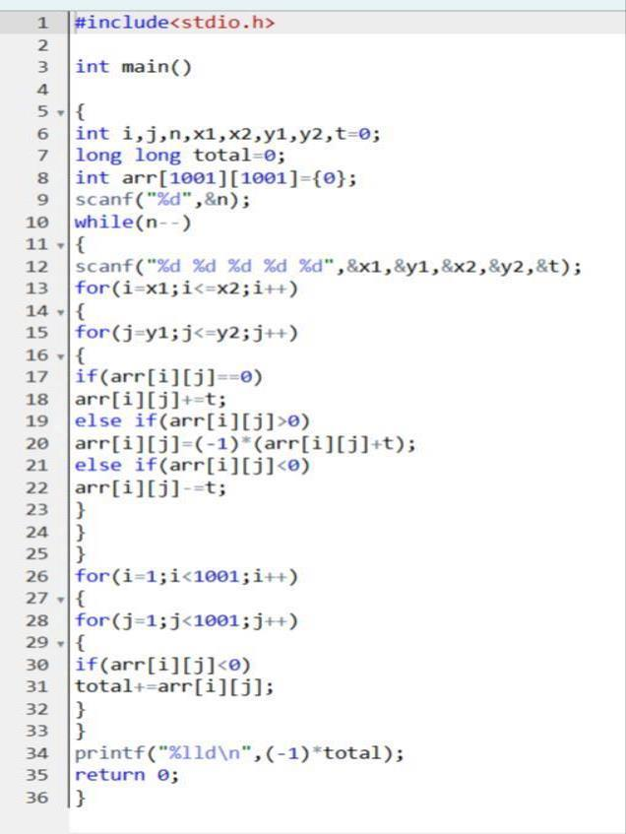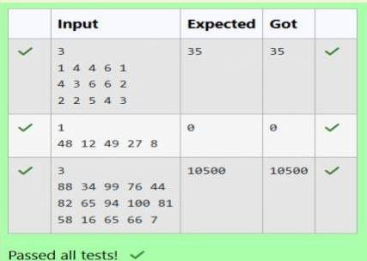

level.

candidate) or 0(for female candidate)The second integer, bi will be the candidate’s talent

two space-separated Integers, ai and bi.The rst integer, ai will be either 1(for a male

The rst line contains an integer N denoting the number of students. Next, N lines contain

Input Format

descending order and then male candidates Are sorted in a descending order.

candidates.The task is to create a list where rst all-female candidates are sorted in a

but thereIs a catch. This time Microsoft wants to hire female candidates rst and then male

create the result list where it wants the candidates sorted according to their talent levels,

levels. Smaller the talent level, lesser is your chance to be selected. Microsoft wants to

which few were males and a few Females. All the students have been assigned talent

Microsoft has come to hire interns from your college. N students got shortlisted out of

Question text

Question 3

